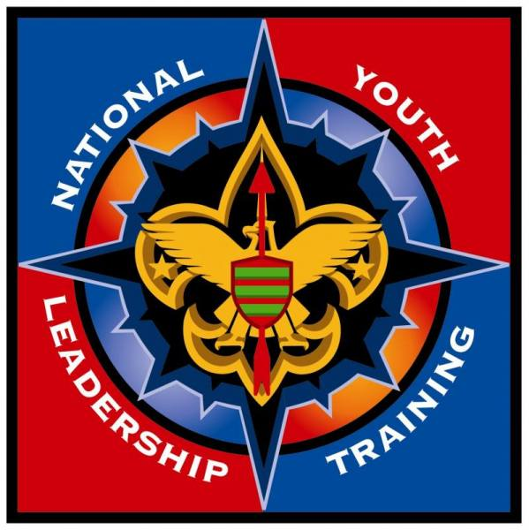
HUDSON VALLEY COUNCIL

National Youth Leadership Training

FAQ - Important Information about NYLT

Why should I attend NYLT?
- You'll have fun;
- The leadership skills we teach will help you throughout your life, within Scouting, in school, at work and later in life;
- Your regular troop/crew job will become easier and more fun;
- You'll have fun;
- You'll see or do something (maybe many things) new and different;
- You'll make new friends;
- You'll get to practice, teach, or show off your Scout skills and learn new outdoor skills;
- You'll have fun!

What do I need to bring to camp...?
A COMPLETE LIST OF GEAR CAN BE FOUND ONLINE (Personal Equipment List).
Pack your gear compactly so that it can be carried by you about 1/2 mile from the CHECK-IN AREA to your campsite in one trip.

NO TRUNKS, SUITCASES, RUBBERMAID BINS, OR FOOTLOCKERS. Your gear should be packed in a backpack (internal or external frame, as desired) and one small hand tote OR small daypack. You will be carrying your gear to your patrol site, so make sure you do not overpack.
Note: Later in the week, you will carry a small subset of your gear on an overnight hike, perhaps up to 3 miles.

CONTRABAND (what to leave home):
- Do not bring tobacco, alcohol, or drugs, petroleum-based flammables (lighter fluid, WD-40, aerosol sprays) or other dangerous substances, laser pointers, weapons or other dangerous items, electronic devices: games, recording or playback devices, cell phones, pagers, iPods, mp3 players, CD/DVD players, etc., or any other items found on the Personal Inventory List under What Not to Bring.
- Any staff member will confiscate contraband on sight, without warning and without providing an opportunity to “keep it packed away.” Confiscated items will be held by the Scoutmaster and returned only to the Scout’s parents at course completion. Any drug violations will be reported to appropriate legal authorities.
- Additionally, any use of tools, supplies, personal or other items, whether contraband or not, that places anyone's health and/or safety at risk or which represents a disregard for the principles of Scouting will be dealt with as a behavior issue.
- “ZERO TOLERANCE” for any of the above.

How many merit badges could I earn?
At NYLT, probably none. NYLT is NOT SUMMER CAMP. It's a week-long outdoor experience for current and future troop/crew/ship youth leaders, utilizing the patrol method. It presents leadership skills in multiple formats (including classroom setting and hands-on practice) providing the opportunity for participants to live and practice these leadership skills. The youth on staff conduct virtually all of the training. The course follows the National NYLT curriculum.

Participants may meet one or more of the requirements for Camping, Cooking, Pioneering and possibly other merit badges, or some parts of Venturing or Sea Scouting requirements as part of the normal activities of the course. Participants who may be pursuing meeting any requirements should consult with their merit badge counselor or advancement chair to establish what requirements will be satisfied on course and what evidence will be required. Please have the advancement or merit badge counselor phone if they have any questions.

What about Uniforms?
- A complete official Scout/Venturing field uniform (“Class A”) or Sea Scouting work uniform is required through morning assembly and at and after dinner, every day. This includes:
- Official tan BSA/ green Venturing/ blue (chambray or Dickies-type) Sea Scouting uniform shirt tucked in, with all patches correctly placed and properly affixed;
- Official BSA/ Venturing uniform pants or shorts /Sea Scouts should wear the official pants or shorts authorized by their ship for wear with the work uniform, typically navy-blue shorts/pants (phone if you have any questions);
- Scout/Venturing/Sea Scouting belt (web or leather);
- Olive Scout/ grey Venturing socks / Sea Scouts wear any non-logoed black socks
- Sturdy, appropriate, closed-toe footwear such as hiking boots
- Home neckerchiefs, slides, and merit badge or OA sashes are to be left safe at home.
- Neckerchief and NYLT hats will be provided at course check-in. Neckerchief will be worn with the full uniform; NYLT hats will be worn at all times outdoors.
- There will be a uniform inspection at every morning assembly, and patrols can gain or lose points in various competitions for their complete uniform appearance.
- Your water bottle is part of your uniform!
- When not required to be in Class A uniforms, participants may be in field activity uniforms (“Class B”) which consists of pants or shorts, belt, socks, and shoes as above, plus a Scout/Venturing/Sea Scout-related (or solid color) T-shirt including but not limited to the course T-shirt (provided at check-in).
- Jeans, and any T-shirt with any commercial or other non-Scout message or logo are not permitted on course. When necessary, sweatshirts, jackets, or raingear may be worn -- these may contain commercial or other non-Scout insignia (Columbia, North Face, parent’s paving company logo, high school sport team, etc.) so long as any staff member does not deem the insignia offensive.
- Shower shoes (flip-flops, slides, etc.) may ONLY be worn in the shower house, not outside.

A SPECIAL NOTE TO PARENTS ABOUT PARTICIPANT UNIFORMS:
Over the years, a variety of comments and questions arise over these uniforming requirements -- and this paragraph tries to address them as fully and frankly as possible. Parents of participants whose home troops/crews/ships are lax on enforcing uniform requirements feel challenged to spend what seems considerable sums of money on uniforming for their participants to meet these requirements. Proper uniforming is part of our program and we will not relax or waive these requirements for any non-health-related (and physician-certified) reason. Nevertheless, it is not mandatory that parents spend a fortune on uniform parts:
- First and foremost, we follow the Scout Law. A Scout is Thrifty -- being careful with money and paying one’s own way. Participants should be earning the funds to pay for their uniforms themselves.
- Participants have the ability to requisition our special “one-armed Maytag” plunger-style manual clothes washers, or make and bring their own. YES! Your participants can wash their own clothes, and we expect them to do so, as needed (bearing in mind that weather conditions will affect how quickly clothing will dry on the outdoor clothesline).
- Many times “experienced” Scout uniforms are available on e-Bay, at garage sales, Goodwill, troop uniform exchanges, and similar sources at very low prices.
- Often uniform parts can be borrowed from other Scouts or Venturers for use on this course.

Please Note: As Venturing uniforms may vary from crew to crew, the official green Venturing shirt with grey pants/shorts, grey Venturing socks, and grey Venturing belt will be the Venturing uniform for this course. For Sea Scouts, if your ship does not use an official work uniform, you should consult the listing for New Century uniform, consisting of the navy Dickies-style shirt and pants/shorts with appropriate Sea Scouting insignia. Since Sea Scouting dress uniforms (especially the summer dress) do not do well in the sometimes-muddy camp environment, they will not be required. Please phone if you have any questions.

What about medications...?
Any participant who is currently taking any prescription medication must have that medication available for inspection as part of medical re-check performed upon arrival at camp. Prescription medication MUST be in its ORIGINAL container and must include full original labeling as received from the pharmacy (including drug name, patient name, and prescribed dosage). Generally, one assigned adult staff member will administer prescription medication; medications will be held by that staff member in a locked storage device. Bee-sting kits/Epipens and asthma inhalers obviously are carried directly by those who require them. Make sure that participants who arrive with these devices know how to store, carry, and use them properly. They will be asked to carry them in their right cargo or right front pocket.

In order for a participant to have any non-prescription medication administered (including Tylenol, Benadryl, etc.) you MUST fill out that section on the Medical Form INCLUDING a parent/guardian signature, along with the medication name, and instructions for its administration; the medication MUST also be listed on the participant’s official health form. Non-prescription medication will be controlled and administered by an adult staff member in the same manner as prescription medication.

A copy of the official BSA medical form (Parts A, B, and C) is the only medical form acceptable for NYLT. Keep the original at home; mail in a copy of Parts A, B, C plus a copy of the front AND back of your insurance card. If your doctor’s office issues a different form with your physician's signature, you must still complete the BSA form but you need not get the doctor’s signature on the BSA form -- simply staple the copy of the other signed form to our form.

All medical forms and unused medicine are returned to you on course completion.

What about bad weather...?
Bearing in mind the overall health and safety of the participants, all course functions will go on as scheduled, weather notwithstanding. ALL participants should come prepared with rain gear, ground cloth(s), and enough clothing to enable them to keep warm and dry regardless of weather. Part of our staff preparation for course includes ensuring that all activities can be held rain or shine. Should storms become severe enough to warrant an adjustment to the schedule, the normal Camp Nooteeming emergency procedures will be followed.

All I'll ever say about behavior.
A brilliant friend of mine puts it best: “Do the right thing. Don’t do stupid stuff.”

The Scout Oath and the Scout Law are the behavior rules at all times, and we expect you will follow them. The course curriculum anticipates proper behavior from all participants at all times. Violations will be dealt with appropriate to their nature, severity, and the overall course goals.

Behavior that places anyone's health and/or safety at risk, or which represents a severe disregard for the principals of Scouting will subject the participant to immediate removal from the course. “ZERO TOLERANCE” is in effect during the course.

Every member of the NYLT staff (both youth and adult) is pledged to follow and to enforce the rules, and to accept no standard below that required by the Scout Oath and the Scout Law from everyone at NYLT at all times, without exception. Or as Vince Lombardi famously said, “Perfection is not attainable, but if we chase perfection, we will surely catch excellence.”

How can I get in touch with my participant...?
Participants cannot receive phone calls. It is an established fact that homesickness is made worse by talking to someone from home. In the event of an emergency, there is at least one cell phone among the staff at all times, and if true need arises, an adult staff member will call you. If an emergency requires a parent/guardian to call the camp, a message can be left at the main Camp Nooteeming office (845-266-5775) or Scoutmaster’s cell. Do not call your participant unless there is a critical emergency that cannot wait -- generally if it’s not critical enough that your participant would need to resign from the course, it’s not critical enough to call about!

There is daily postal delivery at camp, and the Ranger provides mail service to and from the course site.
The NYLT camp mailing address is: Participant’s Name – NYLT
Camp Nooteeming Scout Camp
22 Camp Nooteeming Road
Salt Point, NY 12578

Thank you for reading through the FAQ; please contact the NYLT Scoutmaster if you have any other questions!

