Hudson Valley Council Boy Scouts of America

**2017 Youth and Adult Leadership Training**

**WHAT:** BSA LEAVE NO TRACE TRAINER Course D 78

- Recommended to wear the *Outdoor Ethics Guide* youth position patch

This 16-hour BSA approved course will qualify both youth and adults as BSA LNT trainers. After completing this course, all will be able to teach the LNT Awareness 2 hour course, and youth will be able to hold the *Outdoor Ethics Guide* position in their troop or crew. As young people mature, we will enjoy an increasingly beautiful environment because of the impact of their training in *Leave No Trace and Outdoor Ethics*

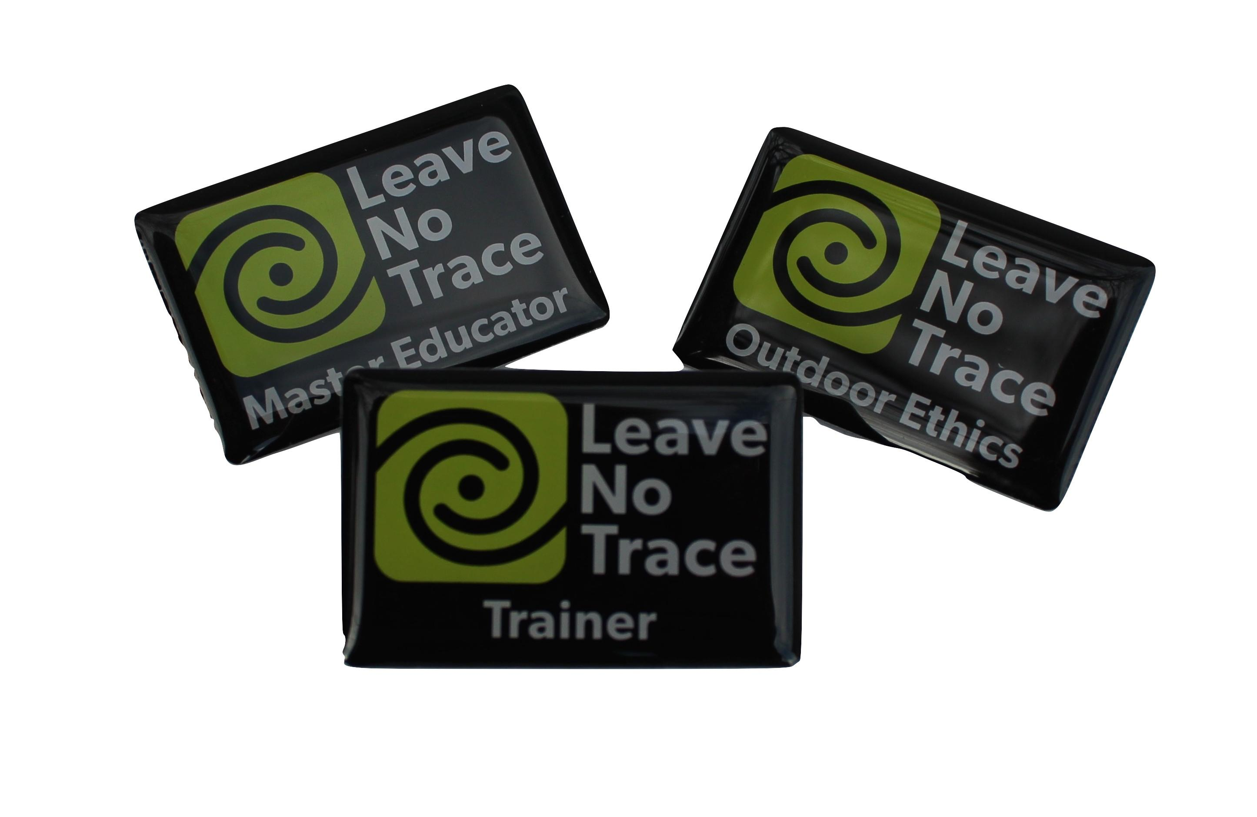

**WHEN:** SAT. 4/22 - 9:00 am - SUN. 4/23/2017 12:00 am

**WHERE:** Camp Bullowa Boy Scout Camp - Dining Hall

Franck Road, Stony Point NY

**WHO:** All BSA registered youth 14 and older

All BSA registered adults

**HOW:**

**1. REGISTER ONLINE** **on Doubleknot at:**

- http://www.hudsonvalleyscouting.org

- Deadline: April 18, 2017 – MUST pre-register online

Minimum # required to run course

- Fee - $25 ADULTS and YOUTH

**2. CHECK-IN:**

- **ALL *must* submit at check-in *BSA Health and Medical Records***

***Parts A & B* form below:** (No physician signature required.)

http://www.scouting.org/filestore/HealthSafety/pdf/680-001_ABC.pdf

- **YOUTH must bring signed *Activity Consent Form* below:**

http://www.scouting.org/filestore/pdf/19-673.pdf

**3. QUESTIONS** contact:

- Xavier DelaRiva [xrys@optonline.net](mailto:xrys@optonline.net) 914-588-6704

- Linda Pallack [lpallack@optonline.net](mailto:lpallack@optonline.net) 845-667-7217

**4. Parking:**

- Park in the lot by Paul Bunyan inside the Camp Bullowa gateway.

- Backpack to the dining hall.

**5. Safe Scouting:**

- Review BSA Sweet 16 of Safety for Scouts and Scouters.

- Know and practice safe sanitation when camping.

**6. Camping:**

- Come prepared to backpack to the dining hall and nearby campsite.

- LEAVE NO TRACE principles will be taught and practiced.

**7. Meals:**

- Simple camp meals will be provided. Contributions of extra side dishes will be appreciated.

- Bring eating utensils.

**8. Program:**

- A LNT Master Educator, Harold Petzold, and BSA-LNT trainers will lead instruction. Previous trained trainers are invited to observe or present

- LNT Principles will be taught with “Quick Concepts” out of doors

- Trainees must present these concepts in their own way to complete the course.

**9. Dress and equipment:**

- Scout uniforms and appropriate camping and eating equioment

- Hiking footwear

- Be prepared for all weather

- BSA Handbook and BSA Field Guide

- Other equipment as needed or interested to share

**10. Trash:**

- “CARRY IN, CARRY OUT”

**11. Fellowship:**

- The activities of this training event encourage fellowship amongst

youth adults and BSA LNT educators.

**13. Recognition:**

- Patches and trainer cards will be presented following the final presentations at the end of the course.

**12. Check-out:**

- Each participant must sign out and take their Health and Medical

Records