Scout Awards and Badges Guide
Contents
STEM and Nova Awards 2
PALA (Presidential Active Lifestyle Award) 3
Hiking Awards 4
Historic Trails Award 5
1777 & 1779 Revolutionary Trails Programs 6
50 Miler Award 7
Service, Conservation, and Scoutcraft Emblems 8
Den Chief Service Award 9
Firem'n Chit 10
Totin' Chip 11
Paul Bunyan Woodsman 12
Boy Scout Outdoor Ethics Awards 13
Boy Scouter Action Award 14
Hornaday Awards 15
Boy Scout World Conservation Award 17
Aquatics Emblems 18
Boardsailing BSA 19
BSA Lifeguard 21
Mile Swim, BSA 24
Snorkeling, BSA 25
Kayaking BSA 26
SCUBA BSA 27
Stand Up Paddle boarding 29
Other Awards and Emblems 30
Interpreter Strips 31
National Court of Honor 33
Recruiter Strip 34
Religious Emblems for Boy Scouts, Varsity Scouts, Venture’s, and Explorers 35
National Summertime Pack Award 36
Cyber Chip Award 38
HVC District Awards 39

STEM and Nova Awards
STEM—Science, Technology, Engineering and Mathematics
STEM is part of an initiative the Boy Scouts of America has taken on to encourage the natural curiosity of youth members and their sense of wonder about these fields through existing programs. From archery to welding, Scouts can't help but enjoy the wide range of STEM-related activities. To support this initiative, the BSA developed the Nova Awards program so that youth members have fun and receive recognition for their efforts.

Why STEM?
We live in a time of great opportunity. The spirit of innovation can help us overcome challenges and ensure a prosperous and secure future. To seize this opportunity, we must position ourselves at the cutting edge of scientific discovery and technological innovation.
Yet our country is falling behind in science, technology, engineering and mathematics. This is why many professionals and educators in science, technology, engineering, and mathematics believe the United States should do more now than ever to encourage students to enter STEM-related fields. These experts say our young people need strong STEM skills to compete in the world market. We must work together to cultivate the next generation of critical thinkers and innovators.

STEM Is the future
Fostering a strong STEM education is our best opportunity to boost the spirit of innovation. It's what we need to help ensure this country continues on a prosperous and secure journey. STEM literacy is also critical because it has a profound and growing impact on our day-to-day lives. Nature, space exploration, and any STEM-related interest reveals to us the beauty and power of the world we inhabit.

What Are the Nova Awards?
The Boy Scouts of America developed the Nova Awards program to excite and expand a sense of wonder in our Scouts. By working with an adult counselor or mentor, the various modules allow them to explore the basic principles of STEM and discover how fun and fascinating STEM can be. The Supernova awards are offered for those who enjoy a super challenge. For more information about STEM and the Nova Awards program, visit http://www.scouting.org/stem.aspx . Discover how the Nova Awards program helps youth be "Prepared. For Life."

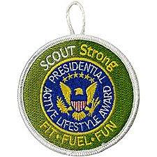
PALA (Presidential Active Lifestyle Award)
WHAT IS “PALA”?
PALA stands for the Presidential Active Lifestyle Award, a program of the President’s Council on Fitness, Sports and Nutrition (PCFSN).
What is the SCOUTStrong™ PALA challenge?
In 2011, the Boy Scouts of America aligned with the PCFSN with the shared goal of together promoting good health for America’s youth. The SCOUTStrong™ PALA Challenge, a Scout-specific PALA challenge, is one of the results of this alliance.
PALA is designed to motivate participants to be physically active on a regular basis by allowing them to participate in activities they enjoy, as well as improving their eating habits. Earning a PALA is definitely doable by anyone at any fitness level.
Who Can Participate in the SCOUTStrong™ PALA Challenge?
This challenge is for anyone, from students to seniors, but it’s geared towards everyone associated with Scouting: Cub Scouts, Friends of Scouting, Boy Scouts and Varsity Scouts, Venturers and Sea Scouts, BSA parents, BSA volunteers, Local council staff, National Council staff, Board members, BSA alumni.
How Does the SCOUTStrong™ PALA Challenge Work?
To earn the SCOUTStrong™ PALA Challenge award, a participant is required to meet a daily activity goal of 30 minutes per day for adults and 60 minutes a day for kids under 18 for at least five days a week, for a total of six weeks. Participants can take up to eight weeks to complete the program.
The participants pick their activities and strive to reach their goals, logging their physical activity along the way. More than 100 indoor and outdoor activities count toward the daily requirement, including walking, running, aerobics, gardening, and canoeing, as long as major muscle groups are engaged at a moderate to vigorous activity level.
Also, each week the participants will focus on a healthy eating goal. Each week participants should add a new goal while continuing with their previous goals. Make ½ your plate fruits and vegetables. Choose lean sources of protein. Consume more whole grains. Consume less salt. Choose low- or no-fat dairy. Eat more seafood. Drink water instead of sugary drinks. Eat smaller portions.
Starting the SCOUTStrong™ PALA Challenge will help participants: • Commit to daily physical activity—and stick with it. • Commit to making healthier food choices—one goal at a time. • Set realistic goals to encourage fitness and healthy eating habits for a lifetime. • Track their progress with either a paper Personal Activity Log (PDF) or by accessing the Online Activity Tracker after creating an individual account.
Go to http://www.scouting.org/SCOUTStrongPALA.aspx to start your challenge.

Hiking Awards
- Historic Trails Award
- 1777 & 1779 Trail Revolutionary Trails Programs
- 50 Miler Award

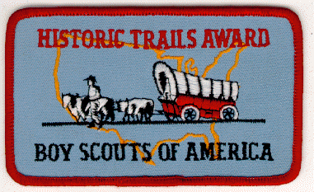

Historic Trails Award

Love of America and devotion to our country depend upon a thorough appreciation of the ideals, principles, and traditions that have made our country strong. Historic Trails Award requirements emphasize cooperation between historic societies and Boy Scout, Varsity Scout, and Venture units. A unit should establish a close relationship with a local society as soon as possible when planning a historic activity - most communities have such societies.
Reports from many units indicate that these societies have been eager to offer their cooperation by
- Suggesting trails or sites that are suitable for unit historic activities and exploration
- Providing units with historic information about the trails or sites
- Offering guidance to units during restoration and marking projects
- Financing the cost of materials used by units for restoration and marking projects
- Staging historic pageants and ceremonies with unit participation
- Directing public attention to unit historic activities through newspapers, television, and radio
Trips outside council boundaries, trips of 500 miles or more, or trips that include aquatics, climbing/rappelling, or shooting sports components require a tour and activity plan to be submitted to the council. You can find more information here: www.scouting.org/scoutsource/HealthandSafety/Alerts/TourActivityPlan.aspx

The Historic Trails Award is available as a Cloth or Leather Patch or a Decal. It is NOT worn on the Uniform, but may be attached to equipment, jackets, backpacks, patch vests or blankets, etc.
To earn this award, members of your unit must plan and participate in a historic activity. A unit historic activity requires members to:
- Locate a historic trail or site and study information relating to it. (The information may be obtained from an adult historic society, public library, or people living near the trail or the site.)
- Hike or camp 2 days and 1 night along the trail or in the vicinity of the site.
- Cooperate with an adult group such as a historic society to restore and mark all or part of this trail or site. (This may be done during the hike or overnight camp.) Or cooperate with such a group to plan and stage a historic pageant, ceremony, or other public event related to this trail or site -- such event should be large enough to merit coverage by the local press.
- Your unit leader must then file the Historic Trails Award application with your council service center.

1777 & 1779 Revolutionary Trails Programs
The American Revolutionary Trails follow the authentic routes of two military expeditions. One is the march of the British Army in 1777 from Stony Point to the attacks on Forts Clinton and Montgomery at Bear Mountain, N.Y. The other follows the American Army in 1779 from Bear Mountain to the battle of Stony Point.

Both trails cross ridges and valleys in the scenic Hudson Highlands. The routes are largely contained in Harriman-Bear Mountain State Parks, and offer some of the most accessible “wilderness” hiking in the northeast. This total package of history and physical challenge is ready made for the Scouting experience.

The trails are 10 & 14 miles long, and have museums, earthworks, and historical markers tracing troop and battlefield movements. As an added attraction, the Trailside Museum at Bear Mountain also has a memorial exhibit dedicated to one of the Scouting’s founding fathers...Daniel Beard.

TRAIL INSTRUCTIONS
Scout leaders should see that their groups get pre-trip training in highway safety, first aid and hiking manners. Short conditioning hikes are also advisable. Units should not race but set the pace by their ability of their slower hikers, so that all can travel as a group during the entire hike.

Approach highway and parkway crossing with caution. Be advised that copperheads and rattlesnakes frequent the park, although they are rarely met on the hiking trails.
Each hiker should carry his own water supply.
Untreated water from streams and lakes is not safe to drink.

Allow adequate hiking time (14 miles for 1779 trail, and 10 miles for 1777 trail), so that your group can also visit museums at Bear Mt. or Stony Point and enjoy other explorations.

Fires may not be built along the trails. Bring a bag lunch instead. Please carry out leftover food and containers. Take along a litter bag, or use your packs and pockets.
Help preserve our parklands and wildlife.
Remember that others follow you. Always “Leave
No Trace.”

These trails are a joint project involving the Palisades Interstate Park Commission,
Cooperative Extension, Hudson Valley Council,
BSA and NY-NJ Trail Conference.

For trail awards, groups can start 1777 trail at pull off on route 9W seven tenths of a mile north of Hudson River power line tower. This avoids trail detour shown on map (Hike into History leaflet).
Also, either fork, where British forces divided, can
be hiked for awards.

50 Miler Award
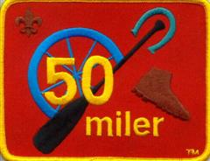
The primary objective of this program is to stimulate Boy Scout, Varsity Scout, and Venturer interest in the ideals of the movement and to promote activity that will result in personal fitness, self-reliance, knowledge of wood lore, and a practical understanding of conservation.
Chartered unit participation is most desirable; however, provisional groups are eligible. This award does not apply if any other is available for a trip.
The Boy Scout, Varsity Scout, or Venturing unit or provisional group must follow these rules for a 50-Miler trip:
- Select a suitable trail or waterway.
- Adult leaders 21 or older must make the entire trip.
Note the following information we have received from the BSA, in regard to a query as to whether the 50 miles may be done on bikes, or on horseback (particularly since the new version of the patch shows a bike wheel and horseshoe):
According to the camping and conservation service, horse is (and "has always been") an acceptable mode of travel for the fifty-miler award.
There's a note in the publishing files for the award application and requirements book - so that "on horse" and "on bicycle" will be specifically included in descriptions of the fifty-miler requirements in the future. Even without that clarification, since requirement 2 says "without the use of motors", there is nothing in the use of horses or bicycles that contradicts that requirement.
The 50 Miler Award is available as a Cloth or Leather Patch or a Decal.
It is NOT worn on the Uniform, but may be attached to equipment, jackets, backpacks, patch vests or blankets, etc.
The 50-Miler Award is presented to each qualifying individual for satisfactory participation in an approved trip. In order to qualify for the award the group of which the individual is a member must fulfill all of the following requirements.
- Make complete and satisfactory plans for the trip, including the possibilities of advancement.
- Cover the trail or canoe or boat route of not less than 50 consecutive miles; take a minimum of 5 consecutive days to complete the trip without the aid of motors. (In some areas pack animals may be used.)
- During the time on the trail or waterway, complete a minimum of 10 hours each of group work on projects to improve the trail, springs, campsite, portage or area. If after checking with recognized authorities, it is not possible to complete 10 hours each of group work on the trail, a similar project may be done in the unit's home area ( There should be no unauthorized cutting of brush or timber.)
- Unit or tour leader must then file a 50-Miler Award application with the local council service center. This application gives additional details about planning the trip.

Service, Conservation, and Scoutcraft Emblems
- Den Chief Service Award
- Firem'n Chit card
- Totin' Chip card
- Paul Bunyan Woodsman patch
- Outdoor Ethics Awareness Award for Boy Scouts
- Outdoor Ethics Action Award for Boy Scouts
- Outdoor Ethics Awareness Award for Varsity Scouts
- Outdoor Ethics Action Award for Varsity Scouts
- William T. Hornaday Awards (Gold Badge and Gold Medal are available to Adults)
- World Conservation Award

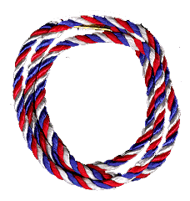

Den Chief Service Award
SEE DEN CHIEF HANDBOOK (33211)
FOR DETAILED REQUIREMENTS
Before you begin work on this service award, discuss with your Den Leader and either your Scoutmaster, Varsity Coach, Venturing Adviser, or Cubmaster the role and importance of the Den Chief.
- Serve the pack faithfully for 1 full year.
- Attend Den Chief Training (if available within year of service) OR be trained by the assistant Cubmaster and den leader.
- Know and understand the purposes of Cub Scouting.
- Help Cub Scouts achieve the purposes of Cub Scouting.
- Be the activities assistant in den meetings. (lead five songs, five stunts or skits, five games, five sports activities)
- Set a good example by attitude and uniforming.(for a minimum of six months)
- Be a friend to the boys in the den.
- Take part in weekly meetings. (for a minimum of six months)
- Assist the den at the monthly pack program.(at least three times)
- Meet as needed with the adult members of the den, pack, troop, team, or crew.
- Complete FOUR of these projects:
  - Serve as a staff member of a special Cub Scouting event, such as a Scouting show, bicycle rodeo, etc.
  - Serve as a staff member of a Cub Scout day camp or resident camp.
  - Advance one rank.
  - Assist in recruiting three new Cub Scouts.
  - Assist three Cub Scouts to become Webelos Scouts.
  - Assist three Webelos Scouts to join a troop.
  - Help to plan and carry out a joint pack-troop activity.
  - Recommend to your Scoutmaster, Varsity Scout Coach, or Venturing Adviser another Boy Scout, Varsity Scout, or Venturer to be a den chief.
The information in GREEN is not in the requirements as listed in Boy Scout Requirements, but is in the details in the Den Chief Handbook.
Note: The Braids shown at the Top of this page ( Red White & Blue) are the Den Chief Service Award Braids.
Pictured below are the Braids worn by Scouts while serving as a Den Chief (Blue & Gold) or as a Webelos Den Chief (Red, Blue & Gold)
Each of these are worn over the left shoulder, (under the epaulet and under the arm). A Scout that has earned the Den Chief Service Award, and is serving as a Den Chief or Webelos Den Chief, may wear both braids.
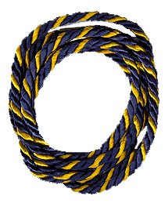 | 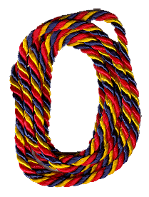
Den Chief | Webelos Den Chief

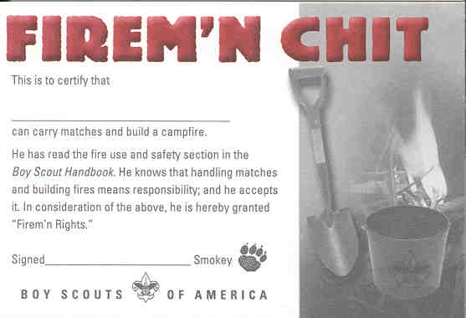 | 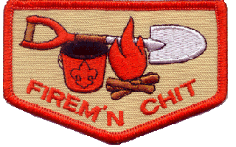

Firem'n Chit

The Official BSA Firem'n Chit is the Wallet Card (No. 34236B) and/or Patch (No. 08599) shown above.
The Firem'n Chit Patch is considered a "Temporary Patch" and, if worn,
should be worn centered on the RIGHT Pocket of the Boy Scout Uniform Shirt.
It should NOT be sewn on a pocket flap

The requirements read as follows:
This certification grants a Scout the right to carry matches and build campfires. The Scout must show his Scout leader, or someone designated by his leader, that he understands his responsibility to do the following:
- I have read and understand fire use and safety rules from the Boy Scout Handbook.
- I will build a campfire only when necessary and when I have the necessary permits (regulations vary by locality).
- I will minimize campfire impacts or use existing fire lays consistent with the principles of Leave No Trace. I will check to see that all flammable material is cleared at least 5 feet in all directions from fire (total 10 feet).
- I will safely use and store fire-starting materials.
- I will see that fire is attended to at all times.
- I will make sure that water and/or shovel is readily available. I will promptly report any wildfire to the proper authorities.
- I will use the cold-out test to make sure the fire is cold out and will make sure the fire lay is cleaned before I leave it.
- I follow the Outdoor Code and the principles of Leave-No-Trace.

The older versions of the Firem'n Chit card (No. 34236 and 34236A), shown below, are also in wide use and are still valid. The wording on the backs of these cards differ from the current requirements.
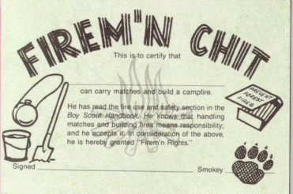
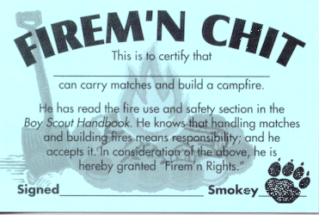

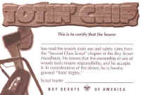 | 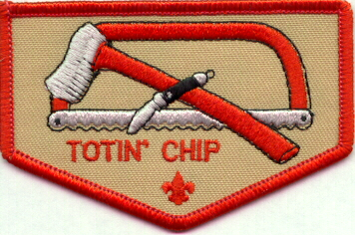

Totin' Chip

The Official BSA Totin' Chip is the Wallet Card shown above (No. 34234B) and/or a Patch (No. 08597).
The Totin' Chip Patch is considered a "Temporary Patch" and, if worn,
should be worn centered on the RIGHT Pocket of the Boy Scout Uniform Shirt.
It should NOT be sewn on a pocket flap

The wording below appears in Boy Scout Requirements (33216). The introductory text in the book reads as follows:
This certification grants a Scout the right to carry and use woods tools. The Scout must show his Scout leader, or someone designated by his leader, that he understands his responsibility to do the following:
- Read and understand woods tools use and safety rules from the Boy Scout Handbook.
- Demonstrate proper handling, care, and use of the pocket knife, ax, and saw.
- Use the knife, ax, and saw as tools, not playthings.
- Respect all safety rules to protect others.
- Respect property. Cut living and dead trees only with permission and with good reason.
- Subscribe to the Outdoor Code.
The Scout's "Totin' Rights" can be taken from him if he fails in his responsibility.

The wording on the back of the Totin' Chip Card shown above, is slightly different, but the requirements are the same (except the introduction and the last part of number 3):
My Responsibility
I will take this card to my Scout leader or someone designated by my leader and do the following:
- Read and understand woods tools use and safety rules from the Boy Scout Handbook.
- Demonstrate proper handling, care, and use of the pocket knife, ax, and saw.
- Use the knife, ax, and saw as tools, not playthings. Use them only when you are willing to give them your full attention.
- Respect all safety rules to protect others.
- Respect property. Cut living and dead trees only with permission and with good reason.
- Subscribe to the Outdoor Code.

The older versions of the Totin' Chip card (No. 4234, 34234 and 34234A), shown below, are also in wide use and are still valid.
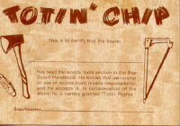 | 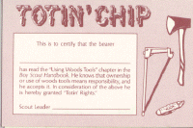
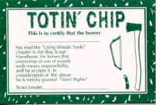
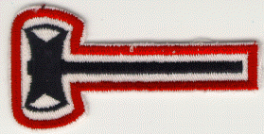

Paul Bunyan Woodsman
TRAIL PACK OR BLANKET EMBLEM

These requirements were revised in the
1996-1997 Boy Scout Requirements Book

Study the Boy Scout Handbook and the Camping merit badge pamphlet, and demonstrate to your Scoutmaster or other qualified person the following:
- Show that you have earned the Totin' Chip.
- Help a Scout or patrol earn the Totin' Chip and demonstrate to him (them) the value of proper woods-tools use on a troop camping trip.
- With official approval and supervision do ONE of the following:
  - Clear trails or fire lanes for 2 hours.
  - Trim a downed tree, cut into 4-foot lengths and stack; make a brush (pile) with branches.
  - Build a natural retaining wall or irrigation way to aid in a planned conservation effort.

In addition to the Patch shown at the top of this page, a wallet card ( No. 34235A) shown below, is available.
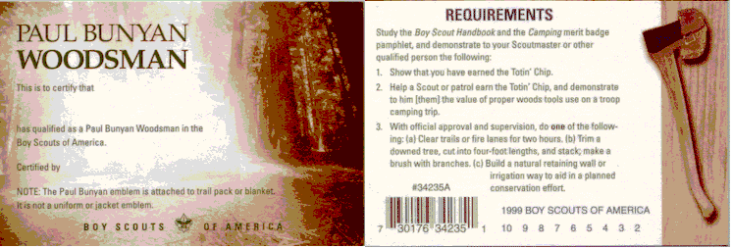

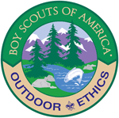

Boy Scout Outdoor Ethics Awards

Boy Scout Outdoor Ethics Awareness Award
Boy Scouts and Scouters interested in learning more about outdoor ethics and Leave No Trace should begin by exploring the Outdoor Ethics Awareness Award.
Requirements:
- Recite from memory and explain the meaning of the Outdoor Code.
- Watch the National Park Service Leave No Trace video. It's on the right side of the page.
- Complete the Leave No Trace online youth course . Print the certificate.
- Earn the Tread Lightly! online course certificate. Print the certificate when you are done.
- Participate in an outdoor ethics course, workshop, or training activity facilitated by a person who has completed the BSA outdoor ethics orientation course or is a BSA outdoor ethics trainer or master.

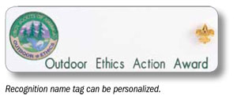

Outdoor Ethics Action Award for Boy Scouts
The Outdoor Ethics Action Award challenges Scouts and Scouters to take affirmative steps to improve their outdoor skills.
Requirements:
- Do the following:
  - Unless already completed, earn the Outdoor Ethics Awareness Award.
  - Complete the BSA outdoor ethics orientation course.
  - Explain how each of the four points of the Outdoor Code guides your actions when outdoors.
- Do the following:
  - Read Chapter 7 of the Boy Scout Handbook on Leave No Trace.
  - Teach a skill related to the Outdoor Code or Leave No Trace to another Scout in your troop or another Scouting unit.
- Complete one of the following:
  - Successfully complete a term as your troop Leave No Trace Trainer.
  - Participate in an outing that emphasizes the complete set of Leave No Trace or relevant Tread Lightly! principles. All members of the troop participating in the outing should use the outdoor ethics and the specific skills needed to minimize impacts from their use of the outdoors.
- Follow the Outdoor Code, Leave No Trace, and Tread Lightly! principles on three outings. Write a paragraph on each outing explaining how you followed the Outdoor Code, Leave No Trace, and Tread Lightly! Share it with your unit leader or an individual who has completed the BSA outdoor ethics orientation course.
- On a troop outing, help your troop on a service activity that addresses recreational impacts related to the type of outing. The project should be approved in advance by the landowner or land manager and lead to permanent or long-term improvements.
- Participate in a report at a court of honor or similar family event on the service activity in Requirement 5.

Boy Scouter Action Award
Requirements:
- Do the following:
  - Earn the Outdoor Ethics Awareness Award.
  - Complete the BSA outdoor ethics orientation course.
  - Discuss with your troop how each of the four points of the Outdoor Code guides your actions when outdoors.
- Read the North American Skills & Ethics booklet to learn about the principles of Leave No Trace. Review the principles of Tread Lightly! Review Chapter 7 of the Boy Scout Handbook and Fieldbook chapters about Leave No Trace, using stoves and campfires, hygiene and waste disposal, and traveling and camping in special environments.
- Facilitate your troop's leadership in planning and leading an outing that emphasizes the complete set of Leave No Trace or Tread Lightly! principles. All members of the troop participating in the outing should use outdoor ethics and the specific skills to minimize impacts from their use of the outdoors.
- Help plan and participate in at least three outings where your troop can follow the Outdoor Code and practice the principles of Leave No Trace and Tread Lightly! Facilitate a discussion at the end of the outings.
- Assist your unit in arranging for a service project emphasizing outdoor ethics with a local landowner or land manager. The project must be approved by the landowner or land manager in advance. Participate in that project. The project should lead to permanent or long-term improvements.
- Make, or facilitate youth in making, a presentation at a roundtable or similar gathering about what your troop did for Requirement 4.
- Help at least three Boy Scouts earn the youth Outdoor Ethics Action Award.
The Outdoor Ethics Awareness and Action Awards Program (for Boy Scouts) - 430-063

Varsity Scout Outdoor Ethics Awards

Varsity Outdoor Ethics Awareness Award
Varsity Scouts and Scouters interested in learning more about outdoor ethics and Leave No Trace should begin by exploring the Outdoor Ethics Awareness Award.
Requirements:
- Recite from memory and explain the meaning of the Outdoor Code.
- Watch the National Park Service Leave No Trace video. It's on the right side of the page.
- Complete the Leave No Trace online youth course. Print the certificate.
- Earn the Tread Lightly! online course certificate. Print the certificate when you are done.
- Participate in an outdoor ethics course, workshop, or training activity facilitated by a person who has completed the BSA outdoor ethics orientation course or is a BSA outdoor ethics trainer or master.

Hornaday Awards

Hornaday Badge
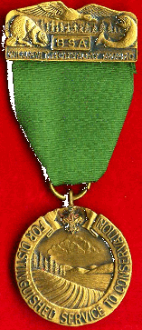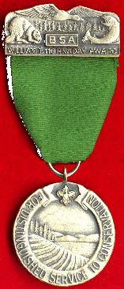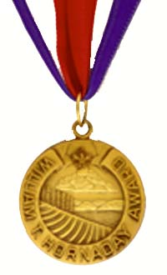
Bronze Medal | Silver Medal | Gold Medal

Square Knot

The William T. Hornaday Awards are for distinguished service in natural resources conservation
Note: The requirements below are based on the requirements printed on the Hornaday Awards Application Forms, which are posted on the official BSA Web Site. The version in the current Boy Scout Requirements Book contains the same general information, but is in a different order (and does not cover the modifications for Venturers.)
Additional information can be obtained from the BSA web site, by clicking here.
Complete requirements are listed on the various Hornaday Award applications, which can be downloaded from BSA's web site by clicking here.
Each project should be equivalent in scope to an Eagle Scout leadership service project. A project planned and carried out as an Eagle Project, which would normally qualify for Hornaday Awards MAY BE USED as one of the Hornaday Projects. One of the other projects can be performed on BSA property.

The Hornaday Awards Program includes a number of levels:
- The Unit Award, which can be earned by Cub Scout Packs, Boy Scout Troops, Varsity Scout Teams, Venturing Crews, and Sea Scout Ships. The Unit Award is a Certificate awarded on the Council Level.
- The Hornaday Badge, which can be earned by Boy Scouts, Varsity Scouts, and Venturers and is also administered on the Council Level.
- The Hornaday Gold Badge, which can be awarded to adult Scouters who have given significant leadership to conservation at a council or district level, and is also administered on the Council Level.
- The Bronze and Silver Medals, which can be earned by Boy Scouts, Varsity Scouts, and Venturers and are administered Nationally.
- The Gold Medal, which is awarded to ADULT Scouters. The Gold Medal is administered Nationally. (No more than 6 are awarded annually.)
- Gold Certificates, which are awarded to Corporations, or Organizations unaffiliated with Scouting. The Certificate is also administered Nationally. (No more than 6 are awarded annually.)
For a history of the Hornaday Award program, click here.

The successful attainment of the youth awards will normally take at least 18 months to accomplish. For the adult awards, the Gold Badge and Gold Certificate require 3 years of service, and the Gold Medal, at least 20 years. The following are highlights of the requirements for the Youth awards (Badge, Bronze Medal, and Silver Medal).
- RANK: Earn First Class rank (Boy Scouts/Varsity Scouts only).
- MERIT BADGES (Boy Scouts/Varsity Scouts only):

Primary Group | Elective Group
Energy | Atomic Energy | Mammal Study
Environmental Science | Bird Study | Nature
Fish and Wildlife  Management | Fishing | Oceanography
Fish and Wildlife  Management | Gardening | Plant Science
Forestry | Geology | Pulp and Paper
Public Health | Insect Study | Reptile and  Amphibian Study
Soil and Water  Conservation | Landscape  Architecture | Reptile and  Amphibian Study
Soil and Water  Conservation | Landscape  Architecture | Weather
  - For the BADGE:
Earn any THREE merit badges from the primary group above, plus any TWO other merit badges from either group.
  - For the BRONZE MEDAL:
Earn the Environmental Science merit badge and THREE others from the primary group plus any TWO other merit badges from either group.
  - For the SILVER MEDAL:
Earn ALL of the merit badges from the primary group above, plus any THREE merit badges from theElective group above.
- In place of merit badges, Venturers must
  - Complete the ecology and plant and wildlife requirements for the Venturing Ranger Award.
  - In addition to the required project documentation, provide specific information on:
  - The research performed in connection with the conservation projects undertaken. The relevant research must be cited at the appropriate location in the conservation project documentation. A bibliography must be provided that lists sources cited. The bibliography must be formatted according to established standards.
  - The applicant's entire Hornaday effort. This evaluation, included in the application in a separate section, should contain information on alternatives considered for each project and an explanation of why each specific conservation project was selected, procedures used, processes used, staffing levels used, funding requirements, and so on.
  - The lessons learned. Included in the report in a separate section, this details what the applicant, in hindsight, would do differently on each project. The section should include recommended changes in project selection; procedures, processes, and staffing levels used; funding requirements; and evaluations of project effectiveness over time.
(See specific information on the following BSA Web page:
http://www.scouting.org/Awards/HornadayAwards/judging.aspx)
- PROJECTS:
  - For the BADGE:
Plan, lead, and carry out ONE significant project in natural resource conservation from one of the following categories:
    - Energy Conservation
    - Soil and Water Conservation
    - Fish and Wildlife Management
    - Forestry and Range Management
    - Air and Water Pollution Control
    - Resource Recovery (Recycling)
    - Hazardous Material Disposal and Management
    - Invasive species control
  - For the BRONZE MEDAL:
Plan, lead, and carry out THREE significant projects in natural resource conservation or environmental improvement, one each from three of the eight project categories.
  - For the SILVER MEDAL:
Plan, lead, and carry out FOUR significant projects in natural resource conservation or environmental improvement, one each from four of the eight project categories.
The complete program of the applicant, as planned and carried out, will be reviewed and approved by the council for the award of the certificate or badge or both and, further, if deemed qualified, will be recommended to the William T. Hornaday Awards Committee for consideration for the Silver or Bronze medals.

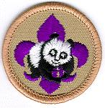

Boy Scout World Conservation Award

The World Conservation Award is worn on the uniform shirt, centered on the right pocket as a TEMPORARY patch. Only ONE Temporary patch may be worn at a time.

The World Conservation Award provides an opportunity for individual Cub Scouts, Boy Scouts, Varsity Scouts, and Venturers to "think globally" and "act locally" to preserve and improve our environment. This program is designed to make youth members aware that all nations are closely related through natural resources and that we are interdependent with our world environment.
As a Boy Scout, you can earn this award by earning the following merit badges:
- Environmental Science merit badge.
- Either Soil and Water Conservation OR
Fish and Wildlife Management merit badge.
- Citizenship in the World merit badge.

Aquatics Emblems
- Boardsailing, BSA
- BSA Lifeguard (Also available to Adults)
- Mile Swim, BSA
- Snorkeling, BSA
- Kayaking, BSA
- Scuba, BSA
- StandUp Paddleboarding

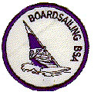

Boardsailing BSA

SWIM TRUNKS EMBLEM
The Boardsailing, BSA Patch is NOT worn on the Uniform.
It is worn on the left side of the swim trunks.

Requirements
- Review the BSA guidelines for boardsailing and explain steps you have taken to follow each of the eleven guidelines found in Section V of Camp Program and Property Management, No. 20-920.
- Explain precautions to be taken for boardsailing on each of the following.
  - Lakes
  - Rivers
  - Ocean or bay areas
- What is hypothermia? Describe to your counselor the symptoms of hypothermia. What special considerations in preventing hypothermia are necessary for boardsailing?
- Properly rig and prepare the sailboard you are using. Point out and explain the function of each of the following: uphaul, outhaul, downhaul, cleat, leach, tack, clew, foot, skeg, centerboard, wishbone boom, universal, luff, and center of effort. Explain how to steer the sailboard.
- Demonstrate your ability to uphaul the sail, find the neutral position to the wind (sail luffing), and control the board's position with foot movement.
- With supervision from your instructor, sail a course that involves beating, reaching, and running. Change tack by coming about.

Purpose
This award has been developed to introduce Scout-age children to basic boardsailing skills, equipment, and safety precautions; to encourage the development of skills that promote fitness and safe aquatic recreation; and to lay a skill and knowledge foundation for those who will later participate in more advanced and demanding activities on the water. Boardsailing BSA is well suited as a program feature for older Scouts at summer camp.
Counselors
Any person recognized and certified as an instructor by Windsurfer International or the United States Boardsailing Association may serve as a counselor for this award with the approval of the local council. A person trained and experienced in boardsailing skills and safety may serve as a counselor for this award in a Scout summer camp program under the direction and supervision of a currently certified Aquatics Instructor, BSA. All requirements must be completed as stated on this Boardsailing BSA application. The counselor should not omit, vary, or add requirements. The requirements should be taught and completed in the order in which they are presented on the application.
Recognition
Scouts completing the requirements will receive a swimsuit patch, No. 00249. A completed award application should be submitted to the local council by the counselor or unit leader.
Teaching Areas
Instruction must be conducted on a body of water meeting the criteria defined in the BSA guidelines for boardsailing. (See the "Aquatics" section of Camp Program and Property Management, No. 20-920.) A steady five- to seven-knot breeze is ideal for beginner practice. Initial water entry and practice should be on a gradual beach that meets Safe Swim Defense standards. The body of water should be free of other traffic, and be protected from shore and open water so that students are within fifty feet of assistance at all times during beginner instruction and practice.
References
A number of useful publications are available from equipment suppliers. The following are recommended:
- The Complete Guide to Windsurfing, by Jeremy Evans
- The Sailboard Book, by Jake Grubb
- Windsurfing, by Roger Jones
- Boardsailing Made Easy, by Chip Winans and Mimi Greenwood

Board Sailing Guidelines
(Found in Section V of Camp Program and Property Management, No. 90-920)
Whenever Scouts or Explorers participate in boardsailing activities, the following guidelines and practices should be followed:
- A responsible adult must supervise all board-sailing activities. The supervising adult must be experienced and qualified in water safety (BSA Lifeguard, Red Cross Advanced Lifesaving, or YMCA Senior Lifesaver) and must be an experienced board sailor or use assistants with such qualifications.
- Only persons who have successfully completed the official BSA swimmers test in the current year may participate in a board-sailing activity.
- All participants must present evidence of fitness assured by a complete health history from a physician, parent, or legal guardian. The adult supervisor should adjust all supervision, discipline, and protection to anticipate any potential risks associated with individual health conditions. In the event of any significant health condition, an examination by a physician should be required by the adult supervisor.
- All participants should receive instruction in boardsailing skills and safety from an experienced board sailor.
- All persons must wear an approved U.S. Coast Guard personal flotation device (type II or III recommended) at all times while participating in a board-sailing activity.
- No one sails alone; always have a buddy on the water (in a boat or on another board). Board sailors must stay within view and easy rescue range of lookout in an appropriately equipped rescue boat.
- No board-sailing at night, at dusk, or in rough water. Weather and water conditions must be known and understood in advance of any board-sailing activity, and weather forecasts should be studied. Exposure suits are recommended for cool water or cool weather.
- Avoid swimming areas, fishermen, and underwater diving activity. Use designated board-sailing beaches when available. Stay out of traffic or channels that have heavy traffic.
- All equipment should be safety checked and repaired as needed before each use.
- When in difficulty, a person should stay with the board and not attempt to swim ashore.
- All participants should know, understand, and follow the rules and procedures for safe board-sailing. The supervisor should encourage the individual exercise of good judgment and self-discipline, and assure that safety rules are fairly and constantly enforced.

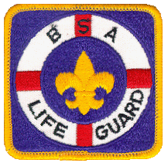

BSA Lifeguard
To be trained as a BSA Lifeguard, you must successfully complete the course as outlined in the BSA Lifeguard Instructor Manual and demonstrate the ability to perform each item specified in the following requirements:
Prerequisites
Before doing requirements 6 through 26, complete the following:
- Submit proof of age. You must be at least 15 years old to participate.
- Submit written evidence of fitness for swimming activities (signed health history).
- Swim continuously for 550 yards, including at least 100 yards each of the following strokes in good form: front crawl, breaststroke, elementary backstroke, and sidestroke.
- Immediately following the above swim, tread water for two minutes using the legs only and with the hands under the armpits.
- Starting in the water, swim 20 yards using a front crawl or breaststroke, surface dive 7 to 10 feet, retrieve a 10-pound object, surface, swim with the object 20 yards back to the starting point with both hands holding the object, and exit the water, all within 1 minute, 40 seconds.
Requirements
Complete the following requirements within a 120-day period:
- Show evidence of current training in American Red Cross First Aid and American Red Cross CPR/AED for the Professional Rescuer or equivalent (includes any training for a camp health officer recognized by BSA national camp standards).
- Demonstrate reaching assists from the deck using an arm, a rescue tube, and a pole.
- Demonstrate throwing assists using a throw bag and a ring buoy with a line attached. Throw each device such that the line lands within reach of a conscious subject 30 feet from shore.
- Demonstrate:
  - Rescue of a conscious subject in deep water using a rescue board, kayak, rowboat, canoe, or other rescue craft that would be available at your local facility.
  - Repeat for an unconscious subject.
- Demonstrate an entry and front approach with a rescue tube to a conscious subject in deep water 30 feet away from shore. Position the rescue tube to support the subject and then assist the subject to safety, providing direction and reassurance throughout.
- Demonstrate an entry and rear approach with a rescue tube to a conscious subject in deep water 30 feet away from shore. Secure and support the subject from behind and then move the subject to safety, providing direction and reassurance throughout.
- Demonstrate use of a rescue tube to assist two subjects grasping each other. Secure, support, and reassure both subjects. With the assistance of a second guard, calm and separate the subjects and move them to safety.
- Demonstrate both front and rear head-hold escapes from a subject's grasp.
- Demonstrate a feet-first entry in deep water with a rescue tube and swim an approach stroke 25 yards within 25 seconds while trailing the tube.
- Demonstrate an entry and front approach with a rescue tube to a face-down passive subject 30 feet away at or near the surface in deep water. Use a wrist roll to position the subject face-up on the rescue tube, tow them to safety, and remove them from the water with assistance within two minutes. Immediately perform a primary assessment and demonstrate one-person CPR for three minutes.
- Demonstrate an entry and rear approach with a rescue tube to a face-down unconscious subject 30 feet away at or near the surface in deep water. Position the subject face-up, tow them to safety, and remove them from the water with assistance within two minutes. Immediately perform a primary assessment and demonstrate two-person CPR for three minutes.
- Demonstrate in-water ventilation of an unconscious subject when prompt removal from the water is not possible. Open the airway, position the mask, and simulate ventilations.
- Demonstrate an entry and approach with a rescue tube for use when an unconscious subject is submerged face-down at or near the bottom in 6 to 8 feet of water. Bring the subject to the surface and tow to the nearest point of safety.
- Remove a subject from the water using each of the following techniques in the appropriate circumstances with the aid of a second rescuer:
  - Vertical lift at the edge of a pool or pier using a backboard
  - Walking assist
  - Beach drag
- Participate in multiple-rescuer search techniques appropriate for a missing subject in murky water:
  - Line search in shallow water
  - Underwater line search in deep water without equipment
  - Underwater line search in deep water with mask and fins
- Demonstrate in-line stabilization for a face-down subject with suspected spinal injury in very shallow water (18 inches or less).
- Demonstrate in-line stabilization for a suspected spinal injury in shallow water (waist to chest deep):
  - For a face-up subject
  - For a face-down subject
- Demonstrate in-line stabilization for a suspected spinal injury in deep water, swim the subject to shallow water, confirm vital signs, and with the assistance of three others, remove the subject from the water using a backboard with straps and a head immobilization device.
- Demonstrate care for a spinal injury on land in the following situations:
  - Non-standing subject
  - Standing subject including securing to a backboard and lowering to the ground
- Correctly answer 80 percent of the questions on the BSA Lifeguard knowledge test covering the course material. Review any incomplete or incorrect answers.
- Serve as a lifeguard, under supervision, for at least two separate BSA swimming activities for a combined time of two hours. Afterward, discuss the experience with the lifeguarding instructor.
Completion Options
Course completion cards are valid only when signed by either a current BSA Aquatics Instructor or BSA Lifeguard Instructor approved by the local council. Training is valid for two years, provided First Aid and CPR/AED for the Professional Rescuer training are kept current during that period.
There are five ways to obtain a course completion card:
- Course Completion — Complete all requirements in the instructor manual during a scheduled course of instruction. The participant must attend all course sessions. Makeup sessions are allowed at the instructor's discretion. If an individual is unable to complete all requirements during the scheduled course, the instructor may elect to continue training until the participant is able to complete all the requirements provided the total elapsed time from start to finish does not exceed the 120-day period.
- Renewal Challenge — Anyone with a BSA Lifeguard completion card that is current or has expired within six months may renew or extend the training by performing requirements 2 through 25 without attending the standard course sessions. Prior to the testing, the instructor may provide a renewal training session to review and update skills and information. Summer camp aquatics directors should renew training for aquatics staff members during precamp training while emphasizing local camp facilities, procedures, and emergency action plans.
- Crossover Challenge — Anyone who holds current training in American Red Cross Lifeguarding, American Red Cross Waterfront Lifeguarding, or other lifeguard training programs may obtain a BSA Lifeguard completion card by performing requirements 1 through 26 without attending the standard course sessions. The lifeguard training program that issued the training certificate must be recognized by the local or state regulatory agency that sets standards for lifeguards at youth camps. The instructor may provide a crossover training session to review and update skills and information prior to the testing. The applicant may receive credit for requirement 26 if within the past 18 months he or she has served as a lifeguard, under supervision, or has supervised lifeguards, for at least two separate BSA swimming activities for a combined time of two hours. Otherwise, due to BSA procedures not implemented at other lifeguarding venues, the applicant must accomplish requirement 26.
- Completion of BSA Aquatics Instructor — Anyone who completes BSA Aquatics Instructor training at National Camping School may obtain a BSA Lifeguard completion card.
- Co-Instructors — Co-Instructors (BSA Aquatics Instructor or BSA Lifeguard Instructor) may each sign a completion card for the other at the conclusion of a BSA Lifeguard course if they satisfy requirements 2 through 24.

BSA LIFEGUARD TRAINING PROCEDURE
- Only those persons currently certified as BSA Aquatics Instructor or as BSA Lifeguard Counselor may train the completion of BSA Lifeguard requirements
- Training as BSA Lifeguard is valid for two years from the date of completion.
- All requirements must be met. (See completion options.)
- The completed application is forwarded to the local council service center, where the individual's training record is annotated.
- To qualify for BSA Lifeguard, the candidate must complete the BSA Lifeguard course under the direction of either a BSA Lifeguard Instructor or a BSA Aquatics Instructor. The course for the BSA Lifeguard is in the BSA Lifeguard Instructor Guide.

In addition to the Patch shown at the top of this page, a wallet card (No. 34260) shown below, is available.
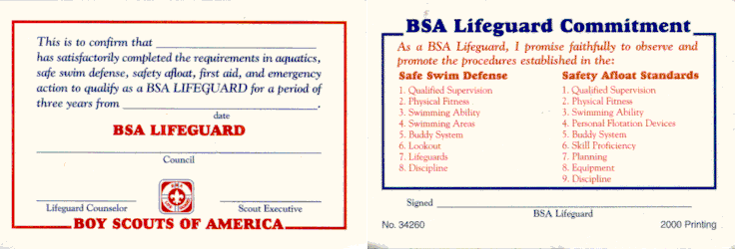

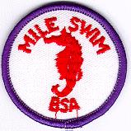 Mile Swim, BSA

SWIM TRUNKS EMBLEM
The Mile Swim, BSA Patch is NOT worn on the Uniform.
It is worn on the left side of the swim trunks.
Adults can also participate in this program at many camps,
but they are NOT authorized to earn or wear the Mile Swim patch shown above.

- Explain how regular exercise contributes to good health and why swimming is one of the best forms of exercise.
- Tell what precautions and procedures a swimmer and escort must follow for distance swimming over open water.
- Under the supervision of a currently qualified certified aquatics instructor, BSA or equivalent, participate in 4 hours of training and preparation for distance swimming (1 hour a day maximum).
- Swim 1 mile over a measured course that has been approved by the trained instructor who will supervise the swim
In addition to the Patch shown at the top of this page, the wallet card ( No. 4246) shown below, is available
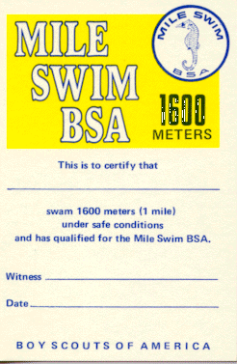

Snorkeling, BSA
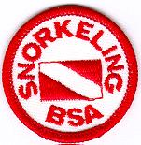
These are the requirements and patch as they appear in "Snorkeling Safety" (Publication No. 19-176B)
SWIM TRUNKS EMBLEM
The Snorkeling, BSA Patch is NOT worn on the Uniform.
It is worn on the left side of the swim trunks.
To encourage youth members to learn and become proficient in snorkeling skills and to snorkel safely.
- Before doing other requirements, successfully complete the BSA swimmer test: Jump feet first into water over the head in depth, level off, and begin swimming. Swim 75 yards in a strong manner using one or more of the following strokes: sidestroke, breaststroke, trudgen, or crawl; then swim 25 yards using an easy, resting backstroke. The 100 yards must be completed in one swim without stops and include at least one sharp turn. After completing the swim, rest by floating.
- Discuss the importance of using the buddy system at all times while snorkeling and list duties of a buddy, beginning with equipment checks.
- Explain the function, fit, and selection of mask, fins, and snorkel. Discuss the use of inflatable flotation vests and PFD’s when snorkeling in open water.
- In confined, shallow water (about waist deep), demonstrate use of mask and snorkel:
  - Show how to prevent the mask from fogging and how to equalize pressure in mask, ears, and sinus cavities. With your head underwater, flood the mask, observe the effect on your vision, surface, and drain the water from the mask.
  - With your face in the water, breathe through the snorkel. Then submerge, surface, clear water from the snorkel, and resume free breathing without removing the snorkel from your mouth.
- In confined, shallow water, demonstrate the use of swim fins: Do first using only fins, and then repeat with a mask and snorkel.
  - Fit and adjust fins to feet.
  - Walk with fins as if entering from a beach.
  - Swim at the surface (10 yards) and underwater (three yards) using the flutter kick.
  - Control direction without using hands while swimming with fins at the surface and underwater.
- In confined, deep water (six to 12 feet), demonstrate:
  - Proper techniques for entering and exiting the water with snorkeling equipment from a dock or boat.
  - Headfirst and feetfirst surface dives, including proper body position for safe ascent and descent.
- Show knowledge of snorkeling signals:
  - Demonstrate divers’ signs and signals, both audible and visual, for use at the surface and underwater.
  - Set out a diver down flag and explain its function.
- In clear, confined water eight to 12 feet deep that has a firm bottom, while swimming with a buddy, use mask, fins, and snorkel to locate and recover an object from the bottom.
- Demonstrate basic survival skills:
  - Float facedown for five minutes while breathing through a snorkel with a minimum of movement.
  - Demonstrate survival floating for five minutes without use of a snorkel.
  - Using fins, show how to tow an exhausted or unconscious buddy to safety.
- Review and explain the eight points of Safe Swim Defense and BSA Snorkeling Safety. Explain training, preparations, and precautions required for snorkeling in open water. Explain environmental factors that affect snorkeling and discuss special precautions needed for oceans, streams, and lakes.
- Explain pressure, buoyancy, and submerged optics and acoustics
related to snorkel swimming and diving.
- Discuss the effects of submersion on the body and how to handle potentially dangerous situations:
  - What is hyperventilation and how is it avoided?
  - What are the symptoms and consequences of hypothermia?
  - Why is CPR training recommended for those participating in swimming and snorkeling activities?
The eight points of BSA Snorkeling Safety are::
- Qualified Supervision
- Physical Fitness
- Safe Area
- Proper Equipment
- Qualified Lifeguards / Lookout
- Ability
- Buddy System
- Discipline

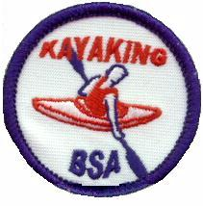

Kayaking BSA

SWIM TRUNKS EMBLEM
The Kayaking, BSA Patch is NOT worn on the Uniform.
It is worn on the left side of the swim trunks.
Requirements
- Before fulfilling the following requirements, successfully complete the BSA Swimmer test.
- Do the following:
  - Describe various types of kayaks and how they differ in design, materials, and purpose.
  - Name the parts of the kayak you are using for this exercise.
  - Demonstrate how to choose an appropriately sized kayak paddle and how to position your hands.
- Do the following:
  - Tell what precautions must be taken for a safe trip afloat.
  - Demonstrate how to select and properly fit a PFD.
  - Explain the importance of safety equipment such as PFD's, air bags, grab loops, and helmets.
- Demonstrate your ability to aid yourself and others in the event of a capsize:
  - Capsize your kayak in water at least seven feet deep, perform a wet exit if necessary, and swim the boat to shore.
  - With assistance, if needed, ready the capsized craft for use.
  - Show how to approach a capsized paddler in your kayak and tow him to shore.
  - While upright in your kayak, right a capsized kayak, empty it of water, and assist the paddler aboard without returning to shore.
- As a solo paddler, demonstrate the following:
  - Entering and launching a kayak from shore or dock.
  - Landing or docking and exiting a kayak.
  - Forward stroke
  - Sweep stroke
  - Reverse sweep
  - Draw stroke
  - Rudder stroke
  - Back stroke
- As a solo paddler, do the following:
  - Paddle forward in a reasonably straight line.
  - Move the kayak sideways to the right and to the left.
  - Pivot 360 degrees to the right and left.
  - Stop the kayak.

NOTE TO SCOUTS:
This badge can be earned concurrently with the Kayaking Merit Badge but earning one does not automatically qualify the Scout as earning the other.
The Worksheets below contain information on, and can be used for, either or both the Kayaking BSA award and the Kayaking Merit Badge, and indicate which requirements correspond in whole or in part to requirements for the other award.
Worksheets for use in working on these requirements: | Format
Worksheets for use in working on these requirements: | Word Format | PDF Format

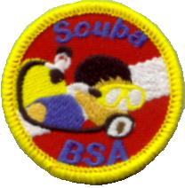

SCUBA BSA

SWIM TRUNKS EMBLEM
The Scuba BSA Patch is NOT worn on the Uniform.
It is worn on the left side of the swim trunks.
Requirements
- Before doing other requirements, successfully complete the BSA swimmer test. To begin the test, jump feet first into water over the head in depth, level off, and begin swimming. Swim 75 yards in a strong manner using one or more of the following strokes: sidestroke, breaststroke, trudgen, or crawl; then swim 25 yards using an easy, resting backstroke. The 100 yards must be completed in one swim without stops and must include at least one sharp turn. After completing the swim, rest by floating.
- Discuss the importance of using the buddy system at all times while scuba diving. Explain that a dive buddy is there to assist with the donning and doffing of equipment, to lend assistance in case of emergency and to share in the underwater experience. Remember, always dive with a buddy — Never dive alone!
- Review hazards associated with scuba diving, including causes of decompression incidents, and safety procedures to avoid them. Explain the importance of never using scuba equipment unless you are enrolled in a training exercise, or have completed a diver certification program, taught by a certified instructor.
By the end of a Water Skills Development session, the participants will be able to meet the following requirements in clear, confined water:
- State the purpose of the following pieces of basic diving equipment: mask, fins, BCD, BCD inflator, regulator, air gauge and alternate air source.
- Describe how to locate the air gauge, and explain how to recognize the “caution zone” on it.
- Don and adjust mask, fins, snorkel, BCD, scuba, and weights with the assistance of a buddy, instructor, or certified assistant.
- While underwater, demonstrate and recognize the following hand signals:
  - Okay?/Okay!;
  - Stop;
  - Up;
  - Down;
  - Out of air;
  - Come here;
  - Ear problem;
  - Slow down/Take it easy;
  - Something is wrong;
  - Watch me;
  - Check your air supply.
- Inflate/deflate a BCD at the surface using the low pressure inflator.
- In shallow water, demonstrate proper compressed air breathing habits; remembering to breathe naturally and not hold the breath.
- Clear the regulator while underwater using both exhalation and purge-button methods and resume normal breathing from it.
- In shallow water, recover a regulator hose from behind the shoulder while underwater.
- In shallow water, clear a partially flooded mask while underwater.
- Swim underwater with scuba equipment while maintaining control of both direction and depth, properly equalizing the ears and mask to accommodate depth changes.
- While underwater, locate and read submersible pressure gauge and signal whether the air supply is adequate or low based on the gauge’s caution zone.
- In shallow water, breathe underwater for at least 30 seconds from an alternate air source supplied by the instructor.
- Demonstrate the techniques for a proper ascent.
*The counselor for Scuba BSA must hold an instructor rating and be in current teaching status with PADI, NAUI, SSI or other member of the RSTC in accordance with BSA scuba policies. Instruction must meet the minimum training standards for introductory scuba experiences set by the RSTC and guidelines provided in the Scuba BSA Brochure, No. 13-971. BSA scuba policies are provided in that brochure and also in the Guide to Safe Scouting.
Information for Counselors
Counselors for Scuba BSA must hold current scuba instructor certification from PADI, NAUI, SSI, or other RSTC member organizations. Instruction must comply with RSTC standards for introductory scuba experiences. These minimum standards include instructor to participant ratios. In a pool, the ratio is eight participants per instructor. In a confined waterfront setting the ratio is four participants per instructor. Ratios may be increased by two participants if the instructor is assisted by someone certified as a dive master or assistant instructor.
A second adult who understands the procedures should be present in case the instructor becomes incapacitated. Two-deep adult leadership is also required by BSA youth protection guidelines.
Before participants are allowed in the water, they must complete a health history form designed for scuba activities. Instructors should use standard forms advocated by their certifying agency.
Skill instruction must be conducted in clear, confined water. A swimming pool is recommended. Scuba BSA is ideally suited to winter programs using indoor pools. Two 45-minute sessions are recommended for instruction, practice, and completion of requirements.
Although Scuba BSA is similar to introductory scuba experiences offered by various RSTC member organizations, those programs are not substitutes for Scuba BSA. All requirements must be completed as stated on the application form. The counselor may not omit, vary, or add requirements. In particular, Scuba BSA has a prerequisite swimming requirement, is only available to youth and adults registered in the Boy Scouting or Venturing programs (minimum age around 10 1/2), and does not include the option of an open-water dive.
Local council programs may not compress or sell air for scuba use, or sell, rent, or loan scuba equipment. All air and equipment for local council Scuba BSA programs must be obtained from properly licensed sources, unaffiliated with the Boy Scouts of America and under the supervision of PADI, NAUI, SSI, or other RSTC-approved and certified scuba instructors.
Individuals completing the Scuba BSA requirements qualify for a recognition card and patch. The counselor or unit leader should submit the completed award application to the local council service center.

Full details, and the application form can be found in the SCUBA BSA pamphlet (No 19-515), available from local BSA Council Service Centers. A copy can be downloaded by clicking here.

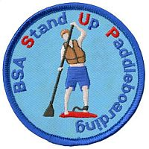

Stand Up Paddle boarding
TEMPORARY PATCH
The stand-up paddle boarding (SUP) emblem is designed to encourage Scouts to develop paddling skills that promote fitness and safe aquatics recreation.
The 3" round emblem features a stand-up paddle boarder against a bright blue twill background, and is worn as a temporary patch..

Requirements
- Review the BSA Safety Afloat policy. Explain to your instructor how this applies to stand up paddle boarding.
- Before fulfilling other requirements, successfully complete the BSA swimmer test: Jump feet first into water over the head in depth, level off, and begin swimming. Swim 75 yards in a strong manner using one or more of the following strokes: sidestroke, breaststroke, trudgen or crawl; then swim 25 yards using an easy, resting backstroke. The 100 yards must be completed in one swim without stops and must include one sharp turn. After completing the swim, rest by floating.
- Explain safety considerations for stand up paddle boarding in the following environments: lake, moving water, whitewater, open ocean, ocean surf.
- Review the characteristics of life jackets most appropriate for stand up paddle boarding and understand why one must always be worn while paddling. Then demonstrate how to select and fit a life jacket for stand up paddle boarding.
- Describe the correct type of leash to wear in the appropriate water venues.
- Name and point out:
  - The major parts of a stand up paddleboard
  - The parts of a paddle for stand up paddle boarding

- Discuss:
  - The different types of stand up paddleboards
  - How to correctly size and hold a paddle for stand up paddle boarding
- Using a properly outfitted stand up paddleboard, demonstrate the following:
  - How to safely carry a stand up paddleboard
  - How to safely paddle away from a dock or shoreline (on knees)
  - How to stand and balance on a board in the neutral position
  - How to appropriately fall off a board
  - How to remount the board
  - Forward stroke
  - Back stroke
  - Forward sweep
  - Reverse sweep
  - Draw stroke
  - One self-rescue technique—lay on your stomach and paddle with your hands
- With supervision from your instructor, paddle a course that involves:
  - A straight line for 25 yards and stop within one board length
  - A figure 8
  - Moving abeam to the right 10 feet and to the left 10 feet

Other Awards and Emblems
http://usscouts.org/awards/intl-active.asp - spirit
- Interpreter Strips (Also available to Adults)
- National Court of Honor Lifesaving and Merit Awards (Also available to Adults)
  - Honor Medal with Crossed Palms
  - Honor Medal
  - Heroism Award
  - Medal of Merit
  - National Certificate of Merit
  - Local Certificate of Merit
- Recruiter Strip
- Religious Emblems

Interpreter Strips
 | German (old version)
 | German (new version)
 | Morse Code

UNIFORM INSIGNIA WORN CENTERED ABOVE
"BOY SCOUTS OF AMERICA" STRIP

Youth and Adult members (Cub and Webelos Scouts, Boy and Varsity Scouts, Venturers, and Sea Scouts, plus Scouters in all programs) may wear this strip if they show their knowledge of a foreign language or the sign language for the hearing impaired by:
- Carrying on a 5-minute conversation in this language.
- Translating a 2-minute speech or address.
- Writing a letter in the language (Does not apply for sign language)
- Translating 200 words or more from the written word.

Morse Code Interpreter's Strip
Special requirements exist for the special Interpreter's Strip for Morse code. The Morse Code interpreter strip designates those who are proficient in Morse Code and denotes their availability for emergency communications and other types of supporting communication for Scouting and the community.
Youth and adults may wear this strip if they show their knowledge of Morse Code by:
- Carrying on a five-minute conversation in Morse Code at a speed of at least five words per minute.
- Copying correctly a two-minute message sent in Morse Code at a minimum of five words per minute. Copying means writing the message down as it is received.
- Sending a 25-word written document in Morse Code at a minimum of five words per minute.

NOTE: The strips shown on the next page are a representative sample of some of the languages available. Others can be ordered through the Council Service Center. Older strips were red and white, while newer strips are khaki-tan and red.

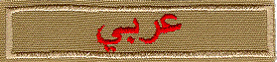 | Arabic
 | Armenian
 | Bengali
 | Cantonese
 | Dutch
 | Finnish
 | French
 | Greek
 | Hebrew
 | Hebrew
 | Italian
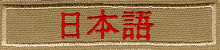 | Japanese
 | Japanese Interpretation
 | Korean
 | Korean (in English)
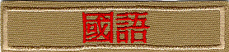 | Mandarin (Traditional)
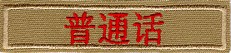 | Mandarin
 | Portuguese
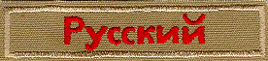 | Russian
 | Signing
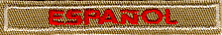 | Spanish
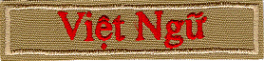 | Vietnamese

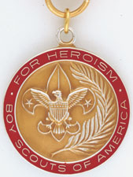
National Court of Honor
Lifesaving and Meritorious Awards

National awards for lifesaving and meritorious acts are made only for outstanding and unusual acts that demonstrate unusual heroism, skill or bravery and reflect Scouting ideals, based on the following criteria:
Lifesaving and Meritorious Awards
This recognition may be given to a member of the Boy Scouts of America—Cub Scout, Boy Scout, Varsity Scout, Venturer, or adult leader—where the evidence presented to the National Court of Honor, in accordance with prescribed regulations, shows that he or she saved or attempted to save life under circumstances that indicate heroism and risk of his or her own life. The court will give consideration to resourcefulness and to demonstrated skill in rescue methods.
Honor Medal with Crossed Palms
The Honor Medal With Crossed Palms may be awarded in exceptional cases to a youth member or adult leader who has demonstrated both unusual heroism and extraordinary skill or resourcefulness in saving or attempting to save life at extreme risk to self.
Honor Medal
The Honor Medal may be awarded to a youth member or adult leader who has demonstrated unusual heroism and skill in saving or attempting to save life at considerable risk to self.
Heroism Award
The Heroism Award may be awarded to a youth member or adult leader who has demonstrated heroism and skill in saving or attempting to save life at minimum risk to self.

Meritorious Action Awards
May be given to a youth member or adult leader of the Boy Scouts of America where evidence presented to the National Court of Honor shows that a significant or outstanding act of service was performed. The action taken need not involve attempts of rescue or risk to self but must put into practice Scouting skills and/or ideals. The awards are the Medal of Merit and the National Certificate of Merit. A Local Council Certificate of Merit is available for recognizing acts that do not qualify for national recognition but should receive some recognition.
Click here for a nomination form.



Recruiter Strip

Cub Scouts and Boy Scouts may be awarded, and wear, below the right pocket on their uniforms, the Recruiter Strip shown above
There are NO formal requirements for these strips Each Unit establishes the procedure for awarding the strip. Usually, a Recruiter Strip is awarded to a Cub Scout or Boy Scout the first time he is successful in getting a friend, relative, classmate, or other acquaintance to join his unit.
Typically, only ONE strip is awarded to a boy while he is a Cub Scout, and another may be awarded while he is a Boy Scout.

Boy Scouts that recruit a new member during special national recruiting drives, can be awarded a special collectible "Scout Recruiter" patch. The design varies from time to time
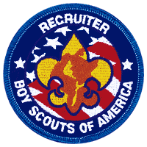

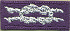

Religious Emblems for Boy Scouts,
Varsity Scouts, Venture’s, and Explorers

A Scout is reverent. He is reverent toward God. He is faithful in his religious duties and respects the convictions of others in matters of custom and religion.
To encourage members to grow stronger in their faith, religious groups have developed the following religious emblems programs. The Boy Scouts of America has approved of these programs and allows the emblems to be worn on the official uniform. The various religious groups administer the programs. Check with your Local council service center or contact the religious organization directly to obtain the curriculum booklets.
Listed below are the BOY SCOUT and VARSITY SCOUT emblems and where to find out about them.
(Unless indicated otherwise below, awards listed may be earned by both Boy Scouts and Varsity Scouts.) Older Boy Scouts of Varsity Scout age (over 14), Venturers, and Sea Scouts (and in some cases, Explorers) are eligible for any awards that Varsity Scouts may earn.
Most of these groups also offer religious emblems for younger youth in the various Cub Scout Programs. For information on the awards available to Tiger Cubs, Cub Scouts, and/or Webelos Scouts, Click Here.
Most of the awards consist of bar pins, ribbons, and pendants, and are worn on the uniform above the left pocket on formal occasions. In addition, the Religious Emblem Square knot, shown at the top of this page, may be worn on the uniform over the left pocket by youth or adults who earned any of the religious awards. One or more miniature devices are affixed to the knot to indicate which level(s) of the award was earned. For more information on the Youth Religious Emblem square knot patch, Click Here. For information on the devices which are attached to the knot, Click Here.
The following faiths or denominations have religious awards for Boy Scouts, Varsity Scouts, Venturers and/or Explorers:

National Summertime Pack Award
Overview
To encourage a pack to be active when school is out for the summer, by doing one activity per month in June, July, and August.
Who Can Earn This Award?
Earned by youth and adult pack members who take part in all three events.
How To Get the Award
Return completed form to council office; some councils provide recognition at no cost, while others charge a nominal fee for items.

- African Methodist Episcopal Church
- African Methodist Episcopal Zion Church
- Anglican Catholic Church
- Anglican Church in North America
- Armenian Apostolic Church of America (Western Prelacy)
- Armenian Church of America (Eastern Diocese)
- Baha'i
- Baptist
- Buddhist
- Catholic, Eastern
- Catholic, Roman
- Christian Church (Disciples of Christ)
- Christian Methodist Episcopal Church
- Church of Christ, Scientist (Christian Scientist)
- Church of Jesus Christ of Latter-day Saints (LDS)
- Churches of Christ
- Community of Christ
- Eastern Orthodox
- Episcopal
- General Church of the New Jerusalem (The New Church)
- Hindu
- Islamic
- Jain
- Jewish
- Lutheran
- Meher Baba
- Moravian
- National Association of Anglican and Traditional Catholic Scouters
- Nazarene
- Polish National Catholic Church
- Presbyterian Church in America
- Presbyterian Church (U.S.A.)
- Protestant and Independent Christian Churches - (Available to any Christian denomination)
- Religious Society of Friends (Quakers)
- The Salvation Army
- Unitarian-Universalist Scouters Organiation
- United Church of Christ
- United Methodist
- United Pentecostal Church International
- Unity Worldwide Ministries
- Zoroastrian

Cyber Chip Award
Today's youth are spending more time than ever using digital media for education, research, socializing, and fun. To help families and volunteers keep youth safe while online, the Boy Scouts of America introduces the Cyber Chip. In developing this exciting new tool, the BSA teamed up with content expert NetSmartz®, part of the National Center for Missing and Exploited Children® and training expert for many law enforcement agencies.
Netsmartz® has created a Scouting portal showcasing Cyber Chip resources, including grade-specific videos, for each level. Check it out here.
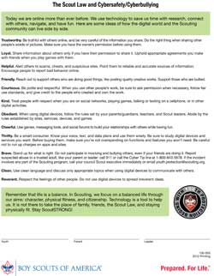
Topics include cyberbullying, cell phone use, texting, blogging, gaming, and identity theft.

Click here to download.

Cyber Chip Requirements
- Grades 1-3
- Grades 4-5
- Grades 6-8
- Grades 9-12
Available From Scoutstuff
- Cyber Chip pocket card (grades 1-5)
- Cyber Chip pocket card (grades 6-12)
- Cyber Chip patch (grades 1-5)
- Cyber Chip patch (grades 6-12)
- Power Pack Pals (bullying), No. 33979
- Power Pack Pals (bullying; Spanish), No. 33980
- Power Pack Pals (Internet safety), No. 33981
- Power Pack Pals (Internet safety; Spanish), No. 34464
Integration Ideas
Boys' Life Articles
  - "Be Safe — and Nice — Online" is designed for younger readers.
  - "Be Cyber Safe (and Smart)" is designed for older readers.
Parents
  - Use the Cyber Chip as a tool to work with your youth to create additional open communications.
  - Visit www.scouting.org/cyberchip and NetSmartz® for more content ideas and tip sheets.
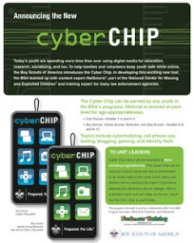
Click here to download.

Unit Leaders
  - Tailor the requirements to your own unit rules. Complete the requirements for the Cyber Chip as a unit at a regular meeting, then hand out the cards and patches on the spot.
  - Review the resources available on the website, including teaching materials, an implementation guide, and more.
  - Create a fun challenge for youth to stump the unit leaders.
  - Play a "Jeopardy!"-style game in a meeting to use what's been learned.
  - Use the Cyber Chip as a foundational step in preparation for leadership positions such as Webmaster.

HVC District Awards
District Award of Merit
District Commissioner’s Award
Lifetime Achievement Award
Louis J. Friedman Award
Larrie Goetz Award
Spirit of Scouting Award
Service to Youth Award
Young Scouter of the Year Award
Eric Huss Award
Community Support Award
District Achievement Award
District Hidden Hero Award
Eagle Support Award
Charter Organization of the Year Award
Venturing Achievement Award
Boy Scout Achievement Award
Troop Committee Chair of the Year
Troop Committee Member of the Year
Cub Scout Achievement Award
Cubmaster of the Year
Assistant Cubmaster of the Year
Pack Committee Chair of the Year
Pack Committee Member of the Year
Webelos Den Leader of the Year
Bear Den Leader of the Year
Wolf Den Leader of the Year
Tiger Den Leader of the Year
Lamp Lighter Award
Unit Hidden Hero Award
Silver Beaver Award

