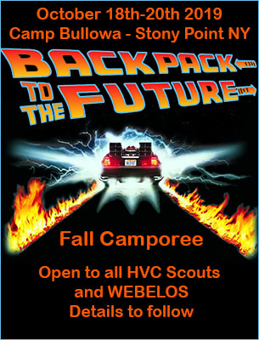
BACKPACK to the FUTURE
FALL CAMPOREE at CAMP BULLOWA
CONCEPT
Each Troop / Crew will pick 2 of the Historical Time Periods listed below. Please indicate 1st and 2nd choice.
Once a time period is approved the unit is “transported” back to that age.
The unit must be dressed in time appropriate costumes (No class A’s required) and behave in the appropriate manner befitting their time. (Following the 12 points of the scout law of course.)
Scouts will travel from time period to time period gathering enough Lightning or Plutonium to generate the 1.21 Gigawatts of Electrical Power to arrive back in 2019.
Doc and Marty will always lend a helping hand, but watch out for Biff and his thugs who could alter the timeline completely.
Adult Leaders or Senior Scouts will man their unit’s specific stations and games.
Scouts will reconvene at the evening campfire where skits or songs depicting their chosen time period are highly encouraged.
Once a time period is selected Mr. Amendola will contact the unit directly and discuss games, costume ideas and answer any questions you may have.
Here are the Historical Eras and Stations…
HISTORICAL PERIODS
These are all first come, first served so register early!
Each Unit please pick 2 historical eras each. First choice and second.
- THE ICE AGE – Rock and Roll Relay | - THE WILD WEST – Bed Head Redemption Shoot Out
- THE EGYPTIANS – Hieroglyphic Scramble | - THE INDUSTRIAL REVOLUTION – Steam Punk Tesla’s Tournament
- THE GREEK EMPIRE – The Brave 300 | - BRITISH EMPIRE – Colonial Expansion Toss
- THE ROMAN EMPIRE – Gladiatorial Combat | - WORLD WAR 1 – No Man’s Land Obstacle Course
- THE VIKINGS – Pick up Thor’s Hammer | - THE RUSSIAN REVOLUTION – Cream Pie Roulette
- THE MONGOL EMPIRE – Genghis Khan Archery Challenge | - PROHIBITION – Cops n’ Gangsters Machine Gum Blast
- THE MIDDLE AGES – The Iron Thrown Challenge | - 1950’s AMERICA – Duck and Cover BBQ
- FEUDAL JAPAN – Sumo Wrestling | - 1960’s MOD – Make S’mores not Wars man…
- THE AZTEC EMPIRE – Stargazer Relay | - DISCO ERA – Panic at the Disco Relay
- THE RENNAISSANCE – Assassin’s Creed Parkour Challenge | - POST APOCOLYPTIC – Brain Eating Competition
- AGE OF EXPLORATION – Find The New World (But avoid the Kraken)
- THE AMERICAN REVOLUTION – The Bullowa Tea Party
- THE FRENCH REVOLUTION – Let Them Eat Cake Contest
- AMERICAN CIVIL WAR – Blue and Gray Relay

