[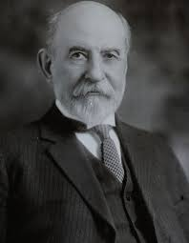](http://www.google.com/url?sa=i&source=imgres&cd=&cad=rja&uact=8&ved=0CAgQjRwwAGoVChMI87voz_rzxgIVhs6ACh0pAgx_&url=http://hornadayscrapbooks.com/about_hornaday&ei=-UiyVbPbAoadgwSphLD4Bw&psig=AFQjCNEbvtXM7TBenndROA2Mos9qhdEcEg&ust=1437833849218034)

## William T. Hornaday

This conservation awards

program was initiated in 1914

by Dr. William T. Hornaday

(December 1, 1854-

March 6, 1937) while director

of the New York Zoological

Park, in an effort to reward

anyone service to conservation.

It then developed into a

partnership with the BSA, but was not totally incorporated into Scouting until after Hornaday's death. For 20 years the program was funded through Hornaday's Permanent Wildlife Protection Fund. Upon his death, the program was sponsored for 35 years by the New York Zoological Society and named in Hornaday's honor. The award is the oldest conservation award given in America.

Dr. Hornaday was an active and outspoken champion of natural resource conservation, and is considered to be one of this country's first advocates for wildlife. His efforts resulted in the recovery of several species and educated countless numbers of people about the importance of environmental awareness. He played a critical role in the establishment of our current zoological system and is personally credited with saving the American bison from extinction. Dr. Hornaday helped pass the Federal Migratory Bird Law, the 1911 Fur Seal Treaty, helped to found the Campfire Clubs of America, and was a longtime supporter of the Boy Scouts of America. Dr. Hornaday believed strongly in the power of youth, that a single individual could make a difference. He also believed that “almost any reform is possible” and his motto was “open wide to youth all gateways to nature.” After his death in 1937, the award was renamed in Dr. Hornaday's honor and became an award of the Boy Scouts of America. In the 1970’s, the present awards program was broadened to include sound conservation and environmental improvement and awareness that will benefit the local community, the region, or the nation.

Additional information can be found on District Website and official BSA Websites

The Hornaday Awards Program emphasis is designed to incorporate an awareness and understanding of conservation as wise and intelligent management of natural resources throughout Boy Scouts of America programs and activities. The BSA National Council describes the Hornaday Award as being “equivalent to an Olympic medal bestowed by the earth.”

The development of good citizens is one of

Scouting's aims and citizens need to practice sound environmental living and conservation of natural resources. This is an extended program that encourages young people to:

• Look at the entire process of resource use

• Analyze how actions and judgments often create problems

• Understand decision-making processes related to the environment

• Seek out commonsense methods that can be applied at home, in the community, state, and in the nation

• Help improve the quality of life

This emphasis is directed toward making those active in Scouting - youth, adult members, and their families - aware of their responsibility for the future. There is an increasing awareness that Scouting members and other individuals are an Integral part of their environment and that their action or inaction affects the quality of life throughout this nation and the world.

Personal experience teaches the most lasting lessons. The conservation program emphasis has been developed to create a positive commitment to improving the environment and conserving natural resources through firsthand experiences and "learning by doing.”

Because Scouting’s youth generally have an active interest in the outdoors, they possess a ready curiosity that can be expanded. These young people can find their own answers, learn how to make sound judgments, and find social and environmental significance in actions that they undertake.

# Hornaday Awards Program

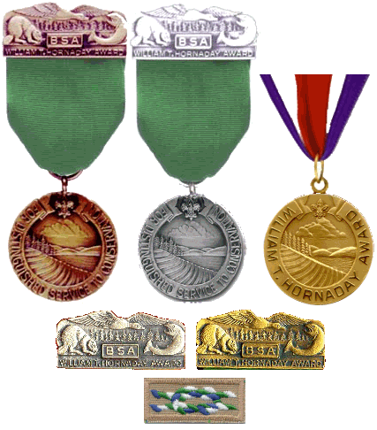

Dr. Hornaday believed strongly in the power of youth, that a single individual could make a difference. He also believed that “almost any reform is possible” and his motto was “open wide to youth all gateways to nature.”

Boy Scouts of America

William T.

Hornaday

Award

## What Qualifies as a Hornaday Project?

**Environmental Science, Energy, Forestry, Fish & Wildlife Management, Soil & Water Conservation, Public Health**

Bird Study, Fishing. Fly Fishing, Gardening,

Insect Study, Weather, Oceanography, Nuclear Science, Geology, Landscape Architecture, Mammal Study, Nature, Plant Science, Pulp & Paper, Amphibian Study

* Energy conservation
* Soil and water conservation
* Fish and wildlife management
* Forestry and range management
* Air and water pollution control
* Invasive plant species control
* Hazardous material disposal & management
* Resource recovery (recycling)

Each project must be a conservation project designed to address a conservation Issue or need in the local area, and it must benefit the environment or the creatures that live there. Making an area more accessible for people is rarely for the benefit of the environment.

Most of the Hornaday awards require the Scout to conduct several significant conservation projects, each covering a different area of conservation. The project must be based on sound scientific principles, address a conservation problem, and contribute to conservation and environment improvement on a Iong-term scale. Scouts are required to plan, lead, and carry out these projects and, as Dr. Hornaday stated, actual results count heavily.

There are no guidelines as to what makes a project "significant,” but choosing and planning a project could make all the difference. Consider this example of a single project executed two ways. A Boy Scout organizes his unit to plant a few hundred seedlings in a burned-over area. A Venturer researches why the area has not naturally regenerated and what species are common to the area conducts an inventory, finds a good source for native plants, organizes a tree-planting event, and obtains community assistance in planting by diligently publicizing the efforts. The following year, the Venturer returns to the area to implement a plant maintenance program, document survival. And assess if replanting is necessary. The actual results-planting the seedlings-for these two projects are the same and some reviewers may consider both significant. However, the results of second project-thorough education of the Scout, the unit, and the community-will stand a better chance of withstanding the rigors of a review.

Nominations for the medals and gold certificate are considered by the national award committee several times a year. The badge, bronze medal and silver medal are youth awards. The age limit for Boy Scouts and Varsity Scouts is their 18'" birthday, and for Venturers, their 21st birthday.

## Merit Badges

## Hornaday Project Categories

## What Qualifies as a Hornaday Project?

## Badge Requirements

* Earn First Class rank (Boy Scouts /Varsity

Scouts only)

* Plan, Iead and carry out at least one project from one of the Hornaday categories.
* Complete the requirements for any
* **THREE merit badges listed in bold type,** plus any TWO others.

## Project Expectations

Applicants are expected to:

* Describe the origination of the idea.
* State the project's purpose and identify the conservation issue it addresses.
* Conduct research, investigation, and study.
* Develop project plans.
* Implement and manage the projects.
* Demonstrate leadership and involve others.
* Describe how the project influenced the attitudes of others.
* Record the time and resources devoted to each project.

## Bronze Medal Requirements

* Plan, Iead, and carry out THREE significant projects in natural resource conservation or environmental improvement, one each from three of the eight project categories.
* Earn the Environmental Science merit badge and **THREE others from the primary group (bolded)** plus any TWO other merit badges from either group.

## Silver Medal Requirements

## Gold Badge/Medal Requirements

* Plan, lead, and carry out FOUR significant projects In natural resource conservation or environmental improvement, one each from four of the eight project categories.
* Earn **ALL SIX (6) of the merit badges from the primary group (bolded)** above, plusany THREE merit badges from the Electivegroup (non-bolded) above.

The Hornaday Gold Badge can be awarded to

ADULT Scouters who provide significant leadership to conservation at a councilor district level for a at least three years. The Hornaday Gold Medal is awarded to ADULT Scouters for leadership and commitment to the education of youth on a national or international level reflecting the natural resource conservation/environmental awareness mission of the Boy Scouts of America over at least twenty years. Nominations must be approved by the BSA's national conservation committee. The Hornaday Gold Medal is the highest attainment in conservation for a Scouter.

A Unit (Pack, Troop, Crew, Ship, etc.) may earn a Hornaday Certificate by fulfilling two requirements. First, the Unit must plan and carry out one conservation project from any of the project categories. Second, the Unit must have at least 60% participation from ALL of its registered youth and adult members in planning and/or carrying out the project. When completed, the Unit will be awarded a certificate by the Council Committee.

## Unit Award